HÀ NỘI UNIVERSITY OF SCIENCE AND TECHNOLOGY
School of Information Communication and Technology

Sofware Design Description

Library Management System
Subject: ITSS Software Development

Group 6
Chử Quốc Hưng
Nguyễn Quốc Huy

Hà Nội, December 7th 2017
Table of Contents

Table of Contents ii
1 Introduction iv
1.1 Objective iv
1.2 Scope iv
1.3 Glossary iv
2 Architecture Design v
2.1 Use case analysis v
2.1.1 Use case Register Account v
2.1.2 Use case Add new Book v
2.1.3 Use case Add new Copy vi
2.1.4 Use case Register to borrow book vii
2.2 Class Diagram viii
3 Interface Design viii
3.1 Interface with other system viii
3.2 User Interface viii
3.2.1 Screen Transition Diagram viii
3.2.2 Screen Design xi
4 Class Diagram xiii
4.1 Design Class Diagram xiii
4.2 Detailed Class Design xv
4.2.1 Add New Book function class diagram: xv
4.2.2 Add New Copy function class diagram: xv
4.2.3 Register Account function class diagram: xvi
4.2.4 Register to Borrow function class diagram: xvi
5 Data Modeling xvii
5.1 ER Diagram xvii
5.2 Design Table xvii
5.2.1 Users table: xvii
5.2.2 Book table xviii
5.2.3 Copy table xix
5.2.4 BorrowInfo table xix
6 Design Patterns Designed and Used xix
6.1 Observer Patterns xix
6.2 Factory Pattern xx
6.3 Template Pattern xxi

Introduction

Objective
This document presents the detailed description for Library management system, user types and their rights at run time. This document also describes the objectives and features of the system, interfaces and constraints of the system in response to external action.
This document is for stakeholder and related software developers.

Scope
This version library management system served 4 main use case: Register Account, Add new book, Add new copy and Register to borrow book. However, login and logout are also added for the system to function properly.
The system also connect to a web service, which manage connection and manipulation into the database.
The whole system can be considered as a small micro-services system

Glossary
The glossary contains the working definitions for the key concepts in the Library System.
User: a person that have an account in the system.
Facebook: a social network
Gmail: email service provided by Google
HUST: Hanoi University of Science and Technology
Study period: expected time to study in school. Example: 2014 - 2019
Borrowing cards: card use to borrow books
Librarian: a person that receives requests from user and takes care of the library everyday
Copy: a version of a book, a book can have many same copies
Overdue: the state of a borrowed book that is not returned after predetermined day
Compensation: money must be paid by borrower for any damage, loss or overdue

Architecture Design

Use case analysis

Use case Register Account
- Boundary Class: RegisterActivity
- Controller Class: RegisterController
- Entities: Data Handler
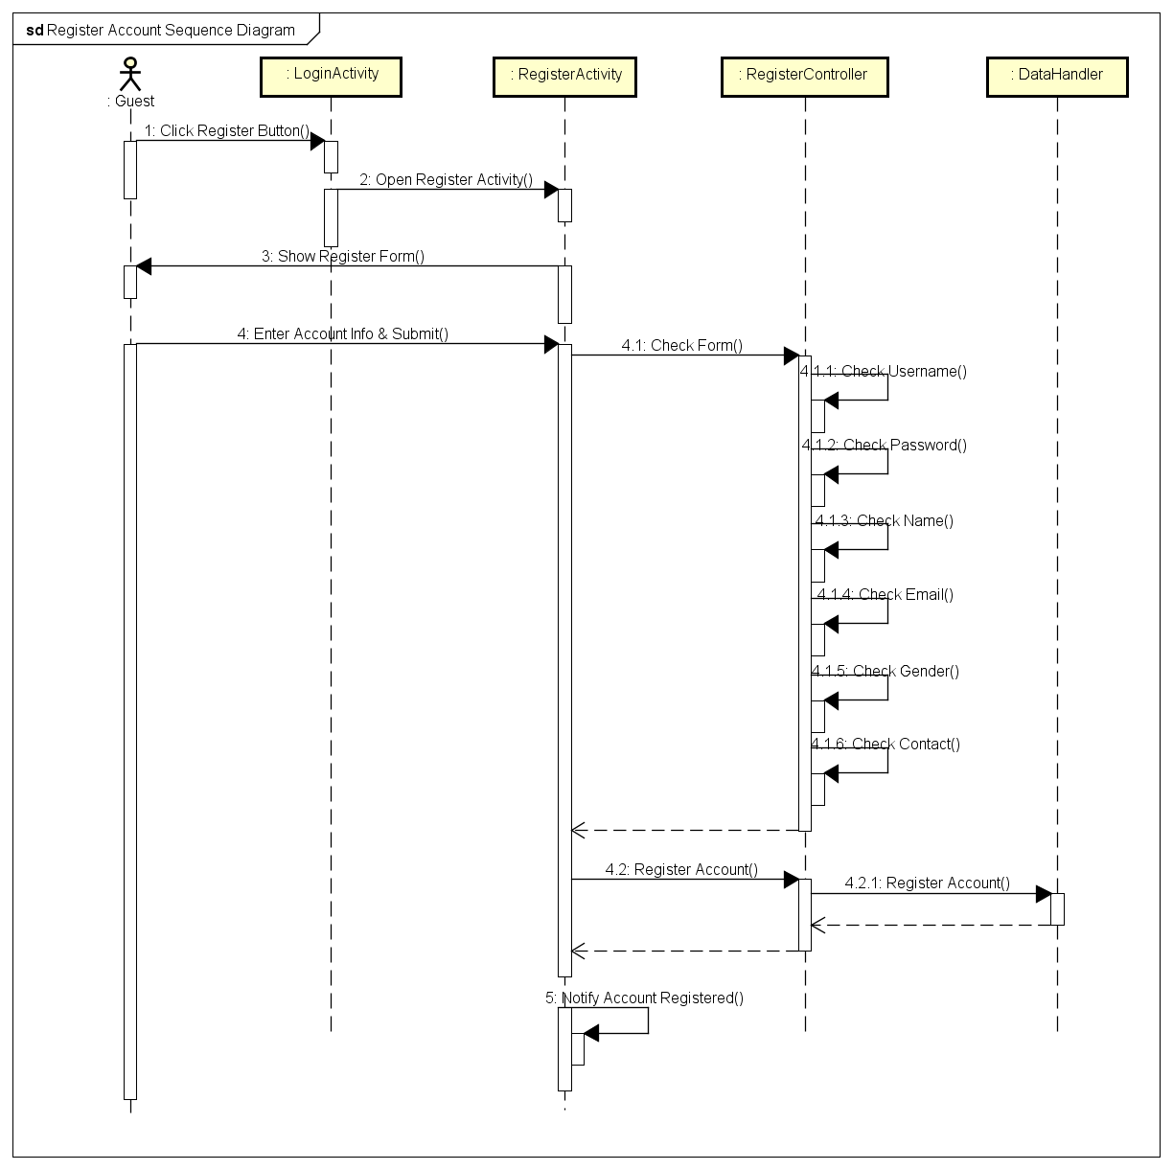

Use case Add new Book
- Boundary Class: AddBookFragment
- Controller Class: AddBookController, BookController, AddCopyController
- Entities: DataHandler, Book
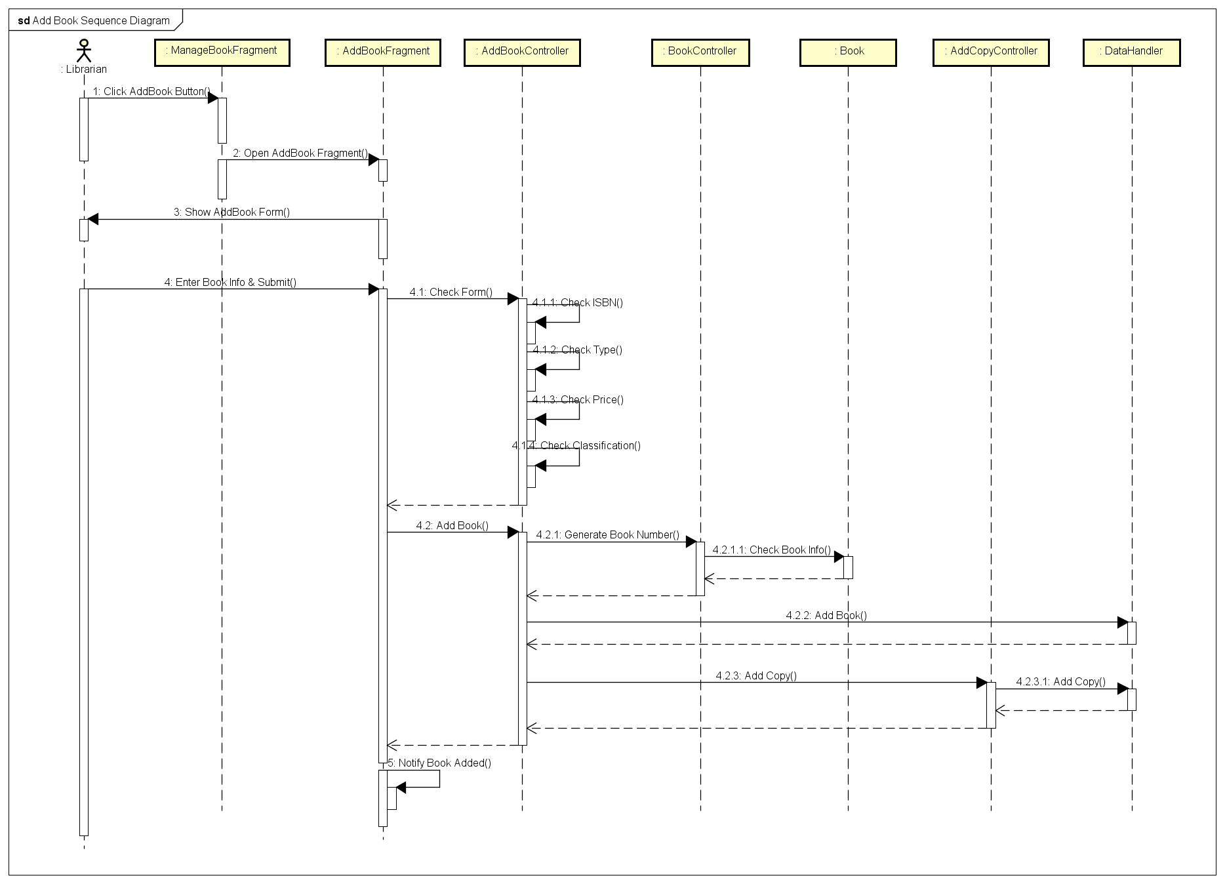

Use case Add new Copy
- Boundary Class: AddCopyFragment
- Controller Class: AddCopyController, CopyController
- Entities: Data Handler, Copy
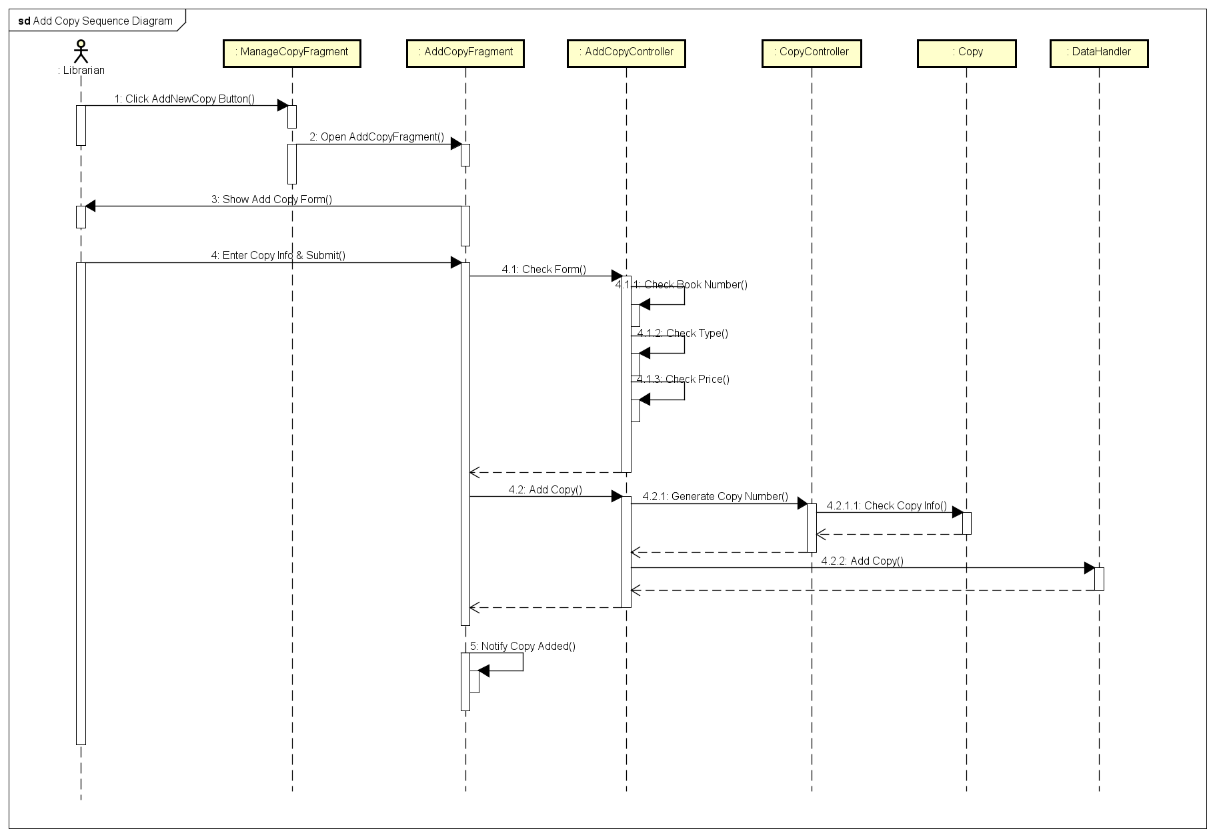

Use case Register to borrow book
- Boundary Class: BookItemView, BorrowBookFragment
- Controller Class: BorrowBookController, CopyController, BorrowInfoController, Book Controller
- Entities: Data Handler, Book, Copy, BorrowInfo
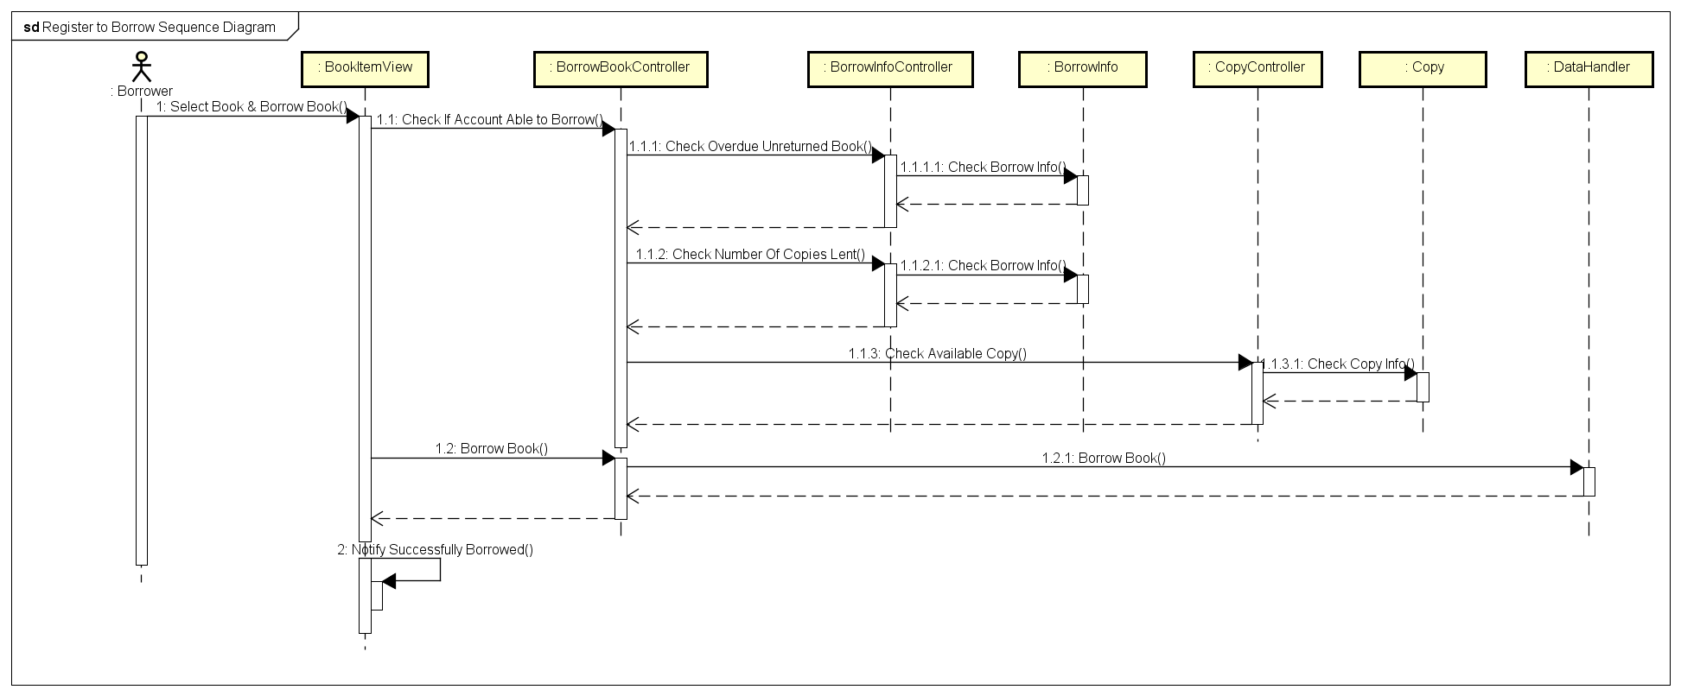

Class Diagram
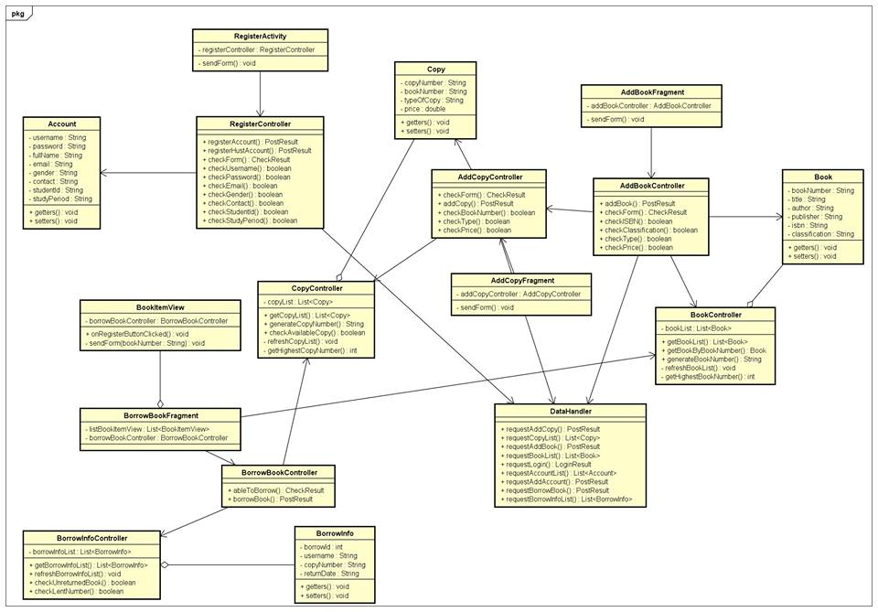

Interface Design

Interface with other system
Library Management System connect to a web service through http request, content type in json format. Each request to service will be match with a return of status code 200, and a status indicating if the request is successful { …, status: true/false }
If any error occur the service will return { error: error_description }

User Interface

Screen Transition Diagram
- Administrator:
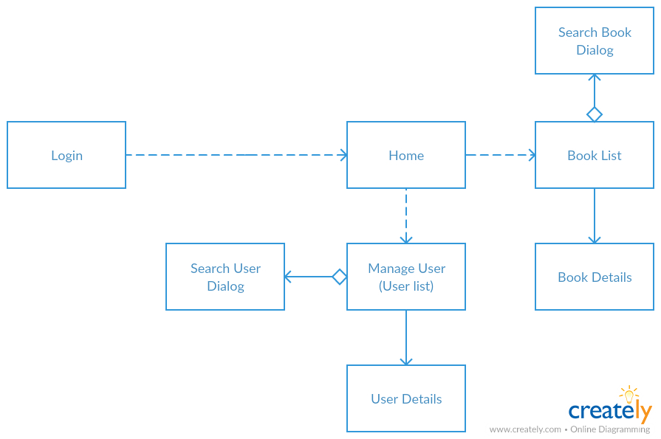
- Borrower and Guest (user):
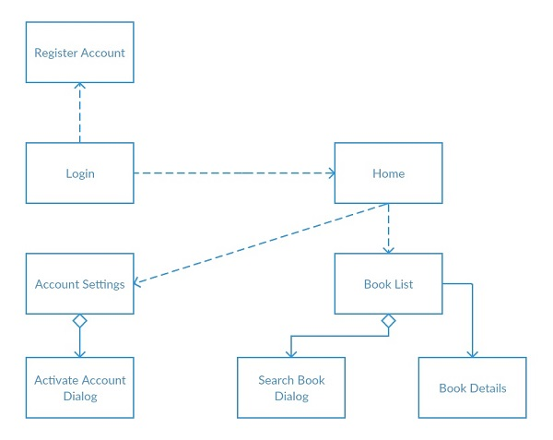
- Librarian:
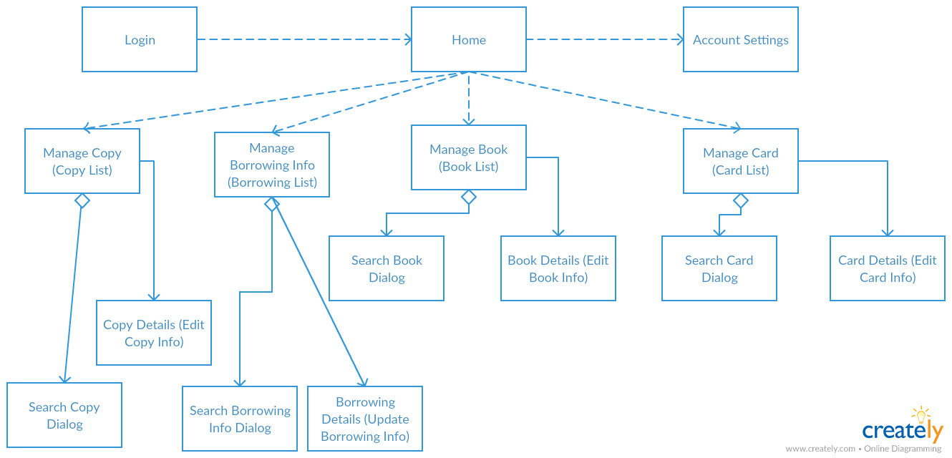

Screen Design
- Login screen:
username input, password input, login button (validate username and password then proceed), register button (trigger register account use case)
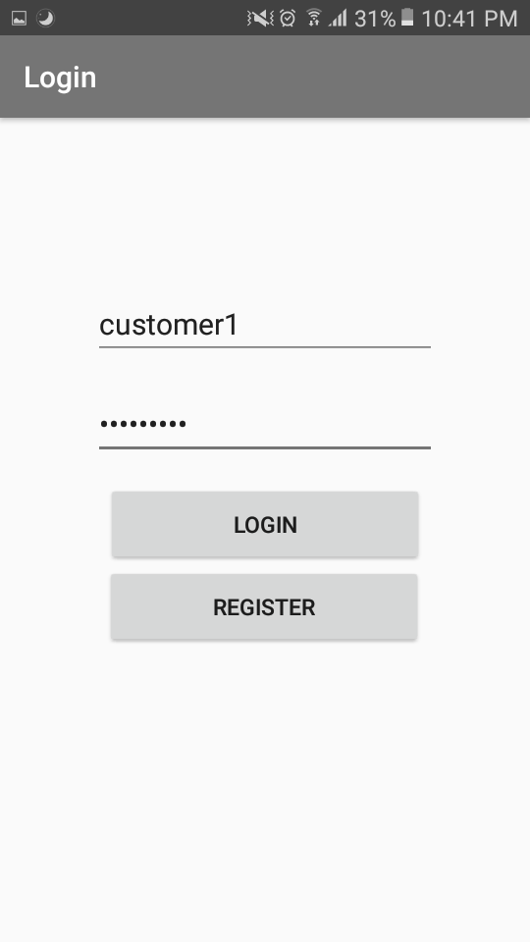
Book list (as a borrower user)
Book search bar, details button for each book, borrow button for each book
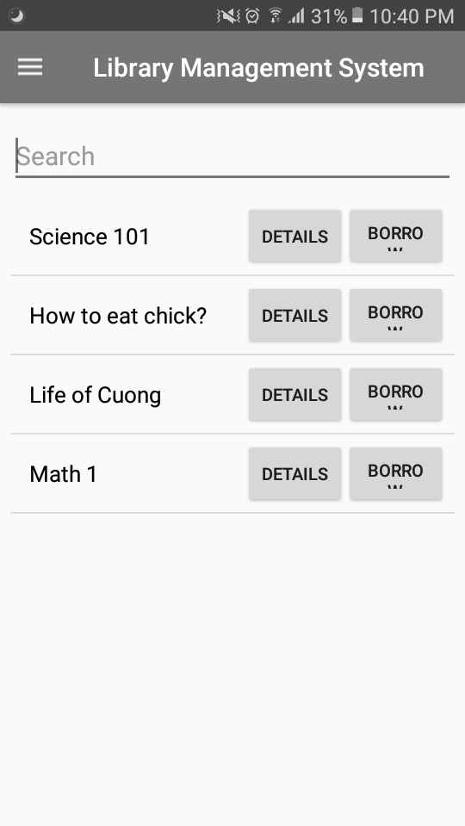

Add new book:
New book information inputs, submit button (validate all inputs then proceed)
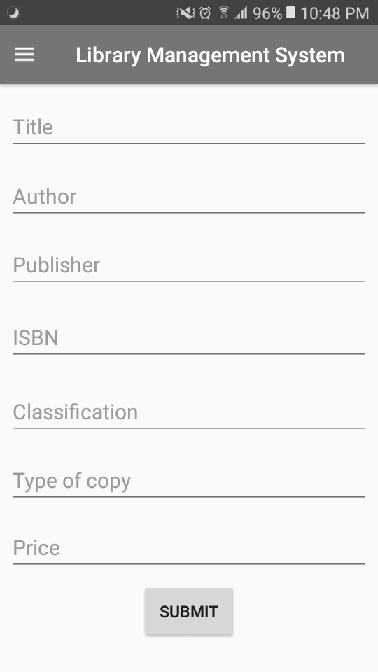
Add new copy:
New copy information inputs, submit button (validate all inputs then proceed)
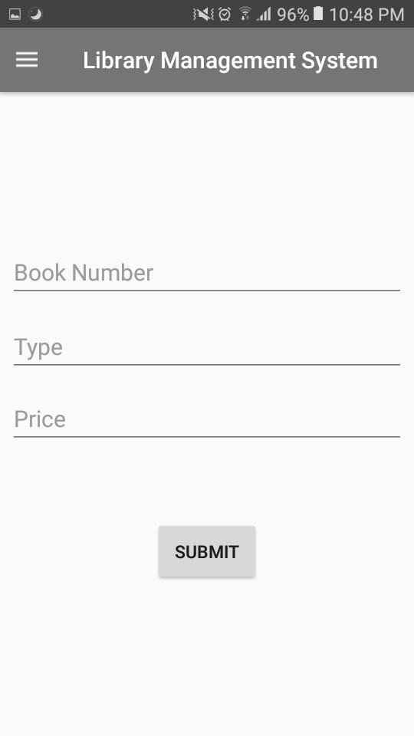

Side menu:
For each kind of user, at each screen after login, there is a side bar (which can be accessed by swipe from left to right) helping user to navigate
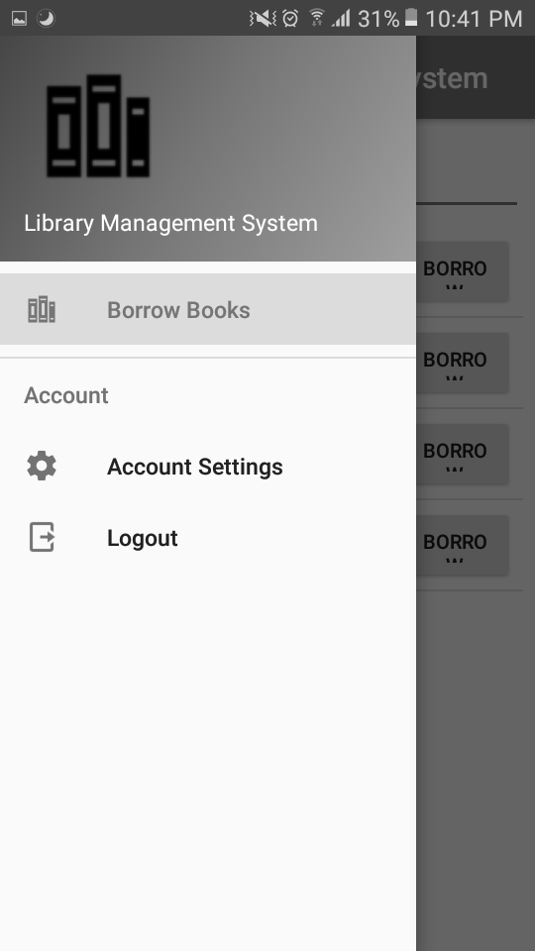

Class Diagram

Design Class Diagram

Detailed Class Design

Add New Book function class diagram:
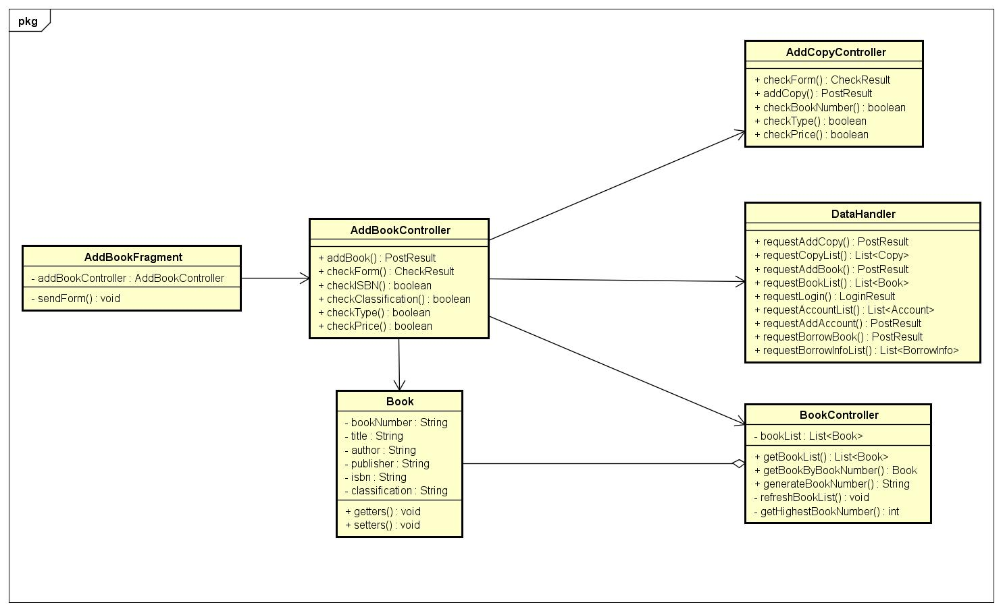

Add New Copy function class diagram:
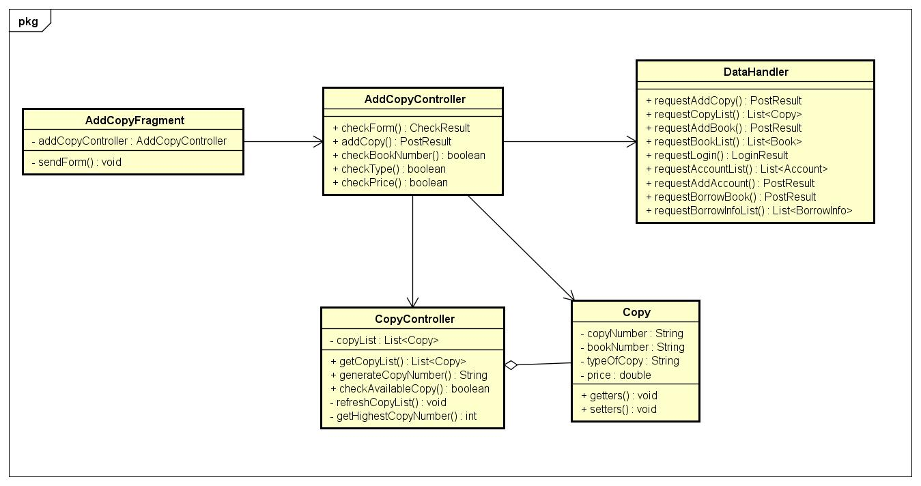

Register Account function class diagram:
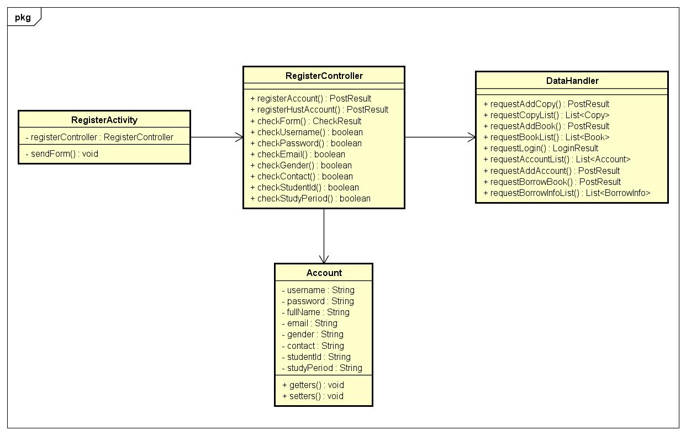

Register to Borrow function class diagram:
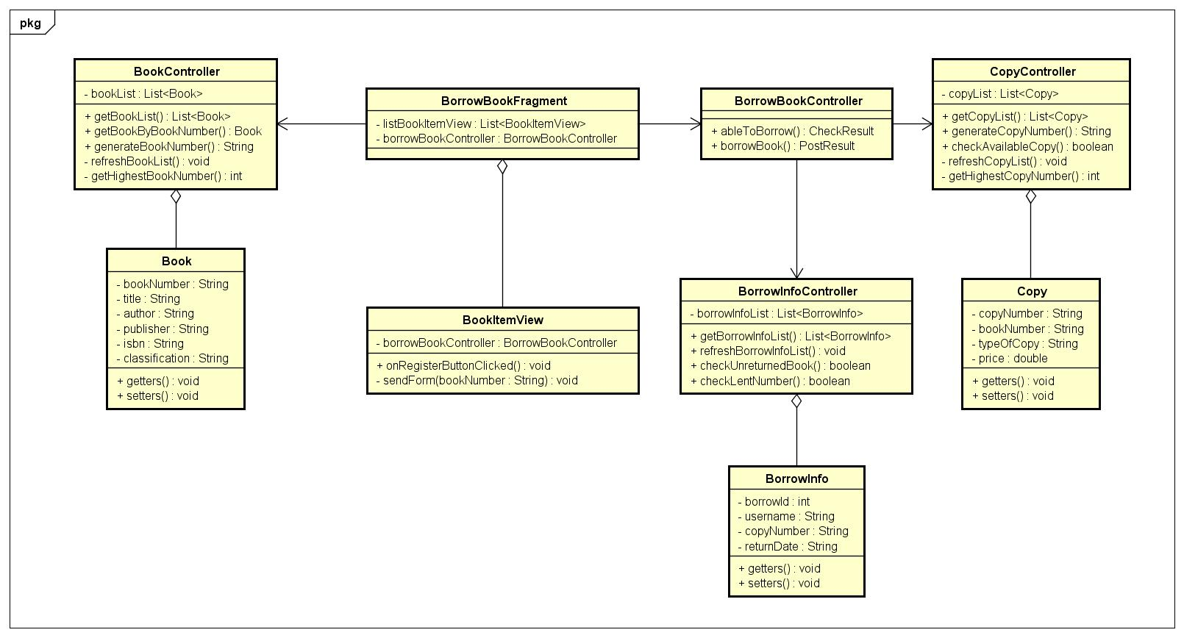

Data Modeling

ER Diagram
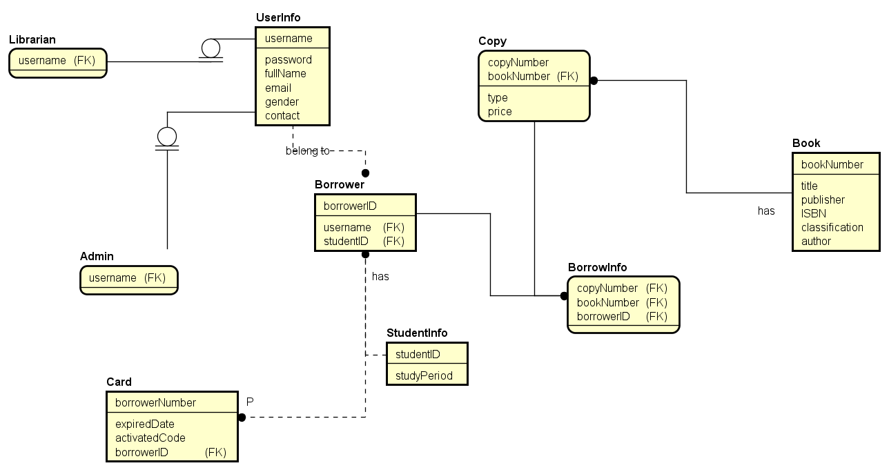

Design Table

Users table:
As user have 3 sub type: Borrower, Administrator, and Librarian. Role column should represent this relationship.
In this case of a mobile application, first impression which is login and register should be fast. Therefore, all type of users will be recorded in 1 table as logging in and classify user type will be faster. Furthermore the numbers of administrator, librarian and borrower that is not student will be very small compared to student borrower (in business logic), we can confidently store 2 column studentId and studyPeriod for every user
Because card verify is another use case which we do not have the responsibility to cover now. We assume every registered user will active their card to borrow. So the card table is omitted in this database.

`CREATE TYPE genderType AS ENUM ('F', 'M');`
`CREATE TYPE roleType AS ENUM ('LIBRARIAN', 'CUSTOMER', 'ADMINISTRATOR');`
`CREATE TABLE users (
username varchar(30) NOT NULL PRIMARY KEY,
password varchar(30) NOT NULL,
fullName varchar(100) NOT NULL,
email varchar(100) NOT NULL,
gender genderType NOT NULL,
contact varchar(100) NOT NULL,
studyPeriod varchar(100) DEFAULT NULL,
studentId varchar(8) DEFAULT NULL,
role roleType NOT NULL
);`

Book table
`CREATE TABLE book (
bookNumber varchar(6) NOT NULL PRIMARY KEY,
title varchar(256) NOT NULL,
publisher varchar(256) NOT NULL,
ISBN varchar(11) NOT NULL,
classification varchar(256) NOT NULL,
author varchar(256) NOT NULL
);`

Copy table
`CREATE TYPE copyType AS ENUM ('REFERENCE', 'BORROWABLE', 'LENT');`
`CREATE TABLE copy (
copyNumber varchar(8) NOT NULL PRIMARY KEY,
bookNumber varchar(6) NOT NULL REFERENCES book (bookNumber) ON DELETE CASCADE,
price float NOT NULL,
type copyType NOT NULL
CHECK (price >= 0)
);`

BorrowInfo table
As stated above, each user is assumed having a card. In real system, each user should have only 1 card at a time, and user will likely request to view past borrowed book of his/her account so store username in borrowinfo is a preferred choice for faster query and reduce requests.
`CREATE TYPE currentBorrow AS ENUM ('REGISTERED', 'ACTIVE', 'RETURNED', 'OVERDUE');`
`CREATE TABLE borrowinfo (
borrowId SERIAL NOT NULL PRIMARY KEY,
username varchar(30) NOT NULL REFERENCES users (username) ON DELETE CASCADE,
copyNumber varchar(8) NOT NULL REFERENCES copy (copyNumber) ON DELETE CASCADE,
current currentBorrow NOT NULL,
borrowDate date NOT NULL,
returnDate date NOT NULL
);`

Design Patterns Designed and Used

Observer Patterns
- Boundary classes (Fragments, Activities) register as Event Listener of UI view components (button, switch…) to listen for: button click event, switch status changed…
- Source code:
- switchButton.setOnCheckedChangeListener(this);
- Register Activity is registered as an observer (implements CompoundButton.OnCheckedChangeListener interface)
@Override
public void onCheckedChanged(CompoundButton buttonView, boolean isChecked) {
if (isChecked) {
studentIdEditText.setEnabled(true);
periodEditText.setEnabled(true);
} else {
studentIdEditText.setEnabled(false);
periodEditText.setEnabled(false);
studentIdEditText.setText("");
periodEditText.setText("");
}
}

Factory Pattern
- Service Factory class uses parameterized Factory Method pattern to create Web Service Object.
- Used to create Book, Copy, Login, Borrow, User Web Service.
- Source Code:
- public <ServiceClass> ServiceClass createService(Class<ServiceClass> serviceClass) {
return retrofit.create(serviceClass);
}

- public <T> T create(final Class<T> service) {
Utils.validateServiceInterface(service);
if (validateEagerly) {
eagerlyValidateMethods(service);
}
return (T) Proxy.newProxyInstance(service.getClassLoader(), new Class<?>[] { service },
new InvocationHandler() {
private final Platform platform = Platform.get();
@Override public Object invoke(Object proxy, Method method, Object[] args)
throws Throwable {
// If the method is a method from Object then defer to normal invocation.
if (method.getDeclaringClass() == Object.class) {
return method.invoke(this, args);
}
if (platform.isDefaultMethod(method)) {
return platform.invokeDefaultMethod(method, service, proxy, args);
}
ServiceMethod<Object, Object> serviceMethod =
(ServiceMethod<Object, Object>) loadServiceMethod(method);
OkHttpCall<Object> okHttpCall = new OkHttpCall<>(serviceMethod, args);
return serviceMethod.callAdapter.adapt(okHttpCall);
}
});
}

- Usage example:
- UserAPI userAPI = ServiceFactory.getInst().createService(UserAPI.class);

Template Pattern
- Template Pattern is used to encapsulate similar methods in BorrowerActivity class and LibrarianActivity class into BaseDrawerActivity superclass;
BorrowBookFragment class, ManageBookFragment class, ManageCopyFragment class, AddCopyFragment class, AddBookFragment class into BaseFragment superclass.
- Usage Example: showSnackbar method in superclass
- public class BaseDrawerActivity extends AppCompatActivity {
protected void showSnackbar(String content) {
Snackbar.make(findViewById(R.id.coordinator_layout), content, Snackbar.LENGTH_SHORT).show();
}
}
- BorrowerActivity and LibrarianActivity extend BaseDrawerActivity:
- public class BorrowerActivity extends BaseDrawerActivity

- public class LibrarianActivity extends BaseDrawerActivity

